ADVANCED JAVA PROGRAMMING PROJECT

NAME: MUKIZA CYIZA Janvier Michel
REG NO: 221009041
CLASS NO: 50

LEVEL 2 BIT GROUP 2

PROJECT NAME: E-Wallet system
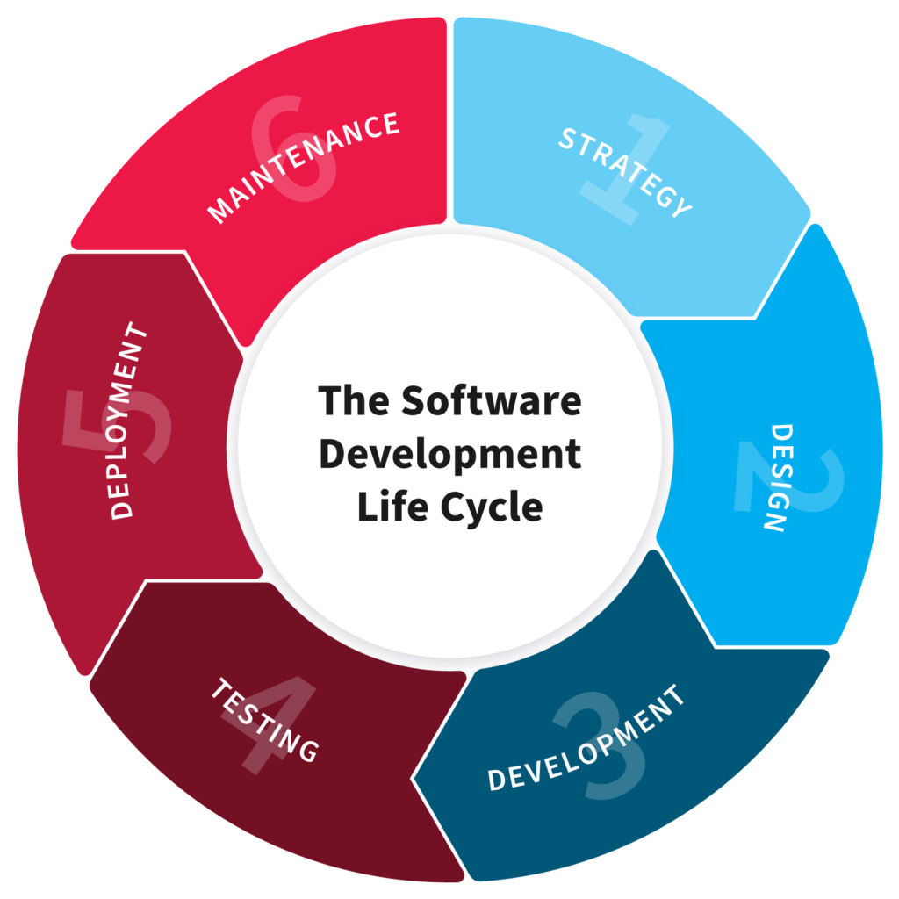

Planning

A digital wallet is an online payment tool or software application that serves as an electronic version of a physical wallet. Also known as an electronic wallet, e-wallet or mobile wallet, it enables users to securely store digital versions of payment methods -- credit and debit cards, gift cards, cryptocurrency, boarding passes, event tickets, passwords and coupons -- to use on the go with their smartphones or smartwatches.

An e-wallet is a secure money management app or online platform that allows you to make purchases with retailers on-site, transfer or send money and track rewards programs. You can link the e-wallet to your bank account or pay as you go with a prepay option.

Goals and objectives of E-Wallet system

A digital wallet (Electronic wallet) is a digital version of a traditional or physical wallet. Users can use a digital wallet to make transactions such as bill payments, mobile recharges, travel/movie bookings, money transfer from one bank account to another, among many others.

Problems of E-Wallet system

According to my experience in E-wallet and Physical wallet, E-wallet developed to solve the following problems:

- As we all know, Physical wallets is very easy to lose or steal. So this point can explain how the E-wallet is very good and important to be used to store our money because electronic wallet consists of user authentication like password, Username, Transaction PIN, Verification code, etc. so even if you can lose your phone, computer or any other electronic device that can help you to access your money on E-wallet, you can gain it anytime with your recorded data in the system and your money but on physical wallet it is not possible to gain what you have lost.

- The other problem to be solved by E-wallet system is this, On physical wallet, management of asset (money) in your wallet is not easy so, E-wallet will make it much easier to manage your assets (money). For example, certain e-wallets like Boost provide a clear overview of your finances for easier bookkeeping.

- Also there is much functionality that would not perform using physical wallet, like electricity pay, gas pay, etc. but E-wallet come to solve the problems that Users can easily pay their electricity, gas, and mobile phone bills using digital wallets. Apart from this, these wallets can be used to book flights, train tickets, and other services. Users can also enable alerts and auto-payment options for timely payment.

- Solving Time management issues. Like moving from one place to another to pay money in cash, you just do it electronically.

- Solving the problems of money saving. Instead of paying money for traveling from one place to another to carry money of buying something and then pay cash you can do all things you want online and then pay your money without much movements so money of transport are saved.

2. Design

To use a digital wallet, a user enters their card information into the digital wallet app or site. The information is encrypted and the wallet is available for use once the device is unlocked and the user authorizes the wallet. To make a mobile payment, the user holds their smartphone close to the contactless terminal.

By using the design of my e-wallet system, the following is how it will work with the technical and functional requirements of the system.

First of all in order to interact with my e-wallet system you will need to have an electronic device like computer, smartphone, Tablet, etc. that will help you to access it. Then you will access it as a web application

You will need to have an account as you see on the picture below
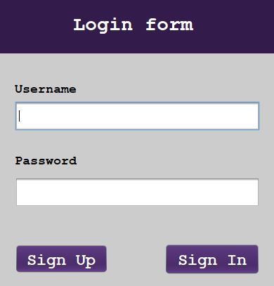

Then if you don’t have an account, you will need to click on Signup button and then link you directly to the registration form as you see on the following picture
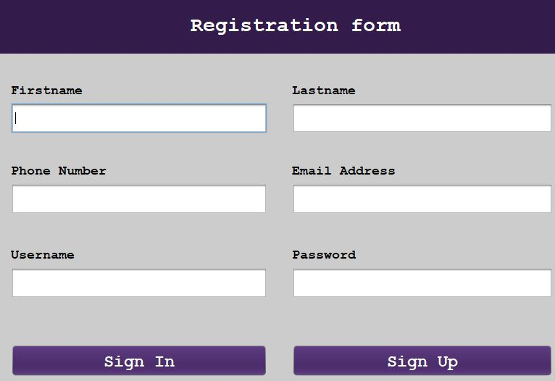

After account successfully created you can click on sign In button to log into your account you have created.
Once you try to click on Sign In without entered your credentials your system will notify you that “Please! Username or Password should not be empty” as you see on the picture below.

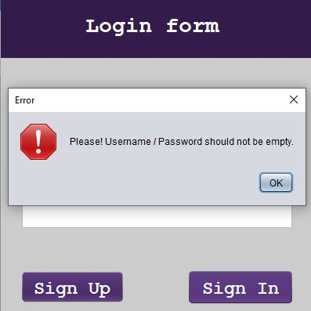

If user credentials not match with what you have used while creating account

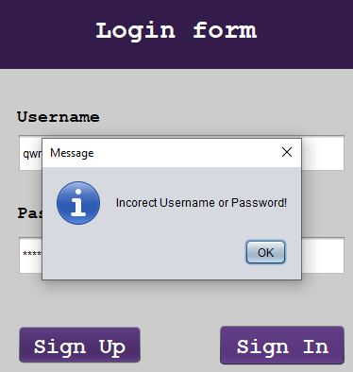

Once your credentials match, then Login will successful and directing you to the home page which is Dashboard.
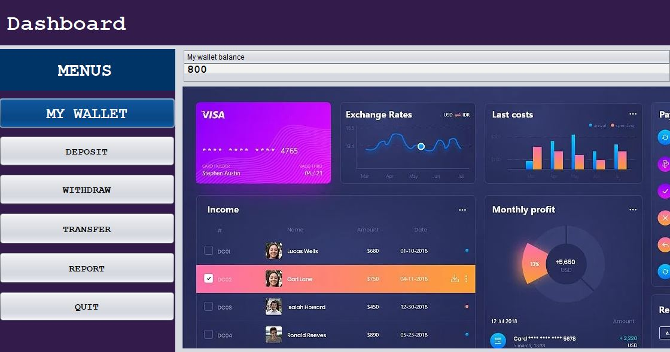

Within the system you can perform different tasks according to the functional requirement of the system like deposit money from one source to this wallet like bank, mobile money, etc.

You can also withdraw money from your wallet and then keep it on your bank account, mobile money account so that you can send to someone who don’t have wallet.

Apart that withdrawal function you can transfer your money to another wallet like paying electricity, water, and any other thing else to someone who sold you the products / services.

Once you have done your activities in the wallet, you can generate the report of what have done as you see on the picture below

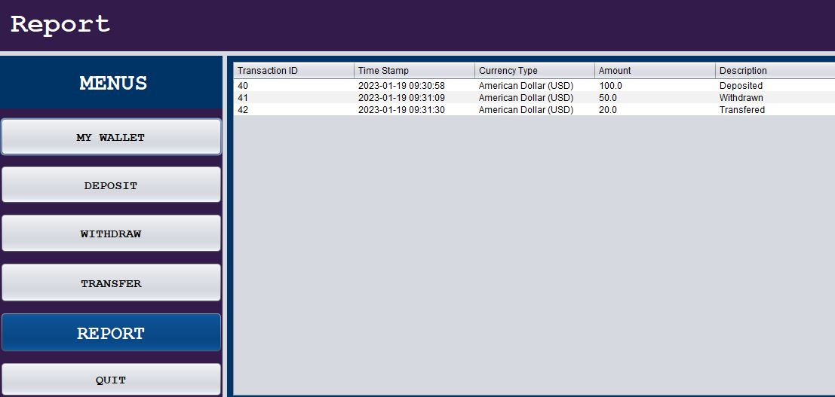

After the completion of your activities in the wallet you can end the session by clicking on the QUIT button to sign out.

3. Development

This development stage is where the software is assembled. This involves a variety of processes, including coding, setting up infrastructure, and creating documentation on how the system works. Developers may work with designers to ensure that their work aligns with the designs.

Some of the programming tools used in this e-wallet system project are as follow:
- Java compiler
- Java interpreter
- Debugger
- Java connector used to connect java codes with database
- Xampp used to interact with database
- NetBean IDE

Programming languages used in e-wallet system project
- Java

- As my team, we developed the e-wallet frontend part of software using swing controls generated from NetBean as I have listed NetBean as one of programming tools used to create forms, button, Labels as well as user interface as whole.
- We developed its backend using Java programming language as well as NetBean IDE
- We used MySql(XAMPP) to interact with database data will hold data of e-wallet backend.
- We used Java connector as a library handling MYSQL connection with the system.

4. Testing

Testing stage is where the development team tests the software for errors and deficiencies. Does the software produce the right results? Does it fulfill the requirements and objectives initially outlined in the system/software development life cycle?

Above questions are the examples of questions that could be asked during this fourth stage of SDLC.

Some teams may test the software manually or use automated testing tools. Whichever route they decided to pursue, the testing process should ensure each unity of the software works well. After undergoing testing, the software should enter a quality Assurance (QA) process to validate the product’s quality.

5. Deployment

Once the software has undergone testing and quality assurance (QA), it is delivered to the customer. This stage usually involves deployment engineer who make software available to customers. They may install the software at a company and/or help individual customers run the application on their computers.

